Regions of the United Stated Theme Park
Your team will work together to create a new theme park for the________________________ region of the United States.

Every great theme park has awesome rides and roller coasters, delicious food to eat, and sometimes even characters for entertainment.

You have each been hired as an expert to represent the state you studied for the state fair.

Every ride, restaurant or snack stand, and character you create for your theme park must represent the states in which you studied.

Every theme park must have a map that shows where the different attractions are located. You get to decide how many attractions there will be in your park. Every attraction you create can be represented on an individual recording sheet.

Be creative. Are rides named after state birds or famous landmarks? Are all of the trees in the park the state trees?

People on my team:

Map Checklist
At least 5 rides
At least 1 restaurant/snack stand
Paths for walking
Each State is Represented
Legend or Map Key
Landforms typical to this region
Creative name of park
Color and neatness
Example of a theme park map with a key:
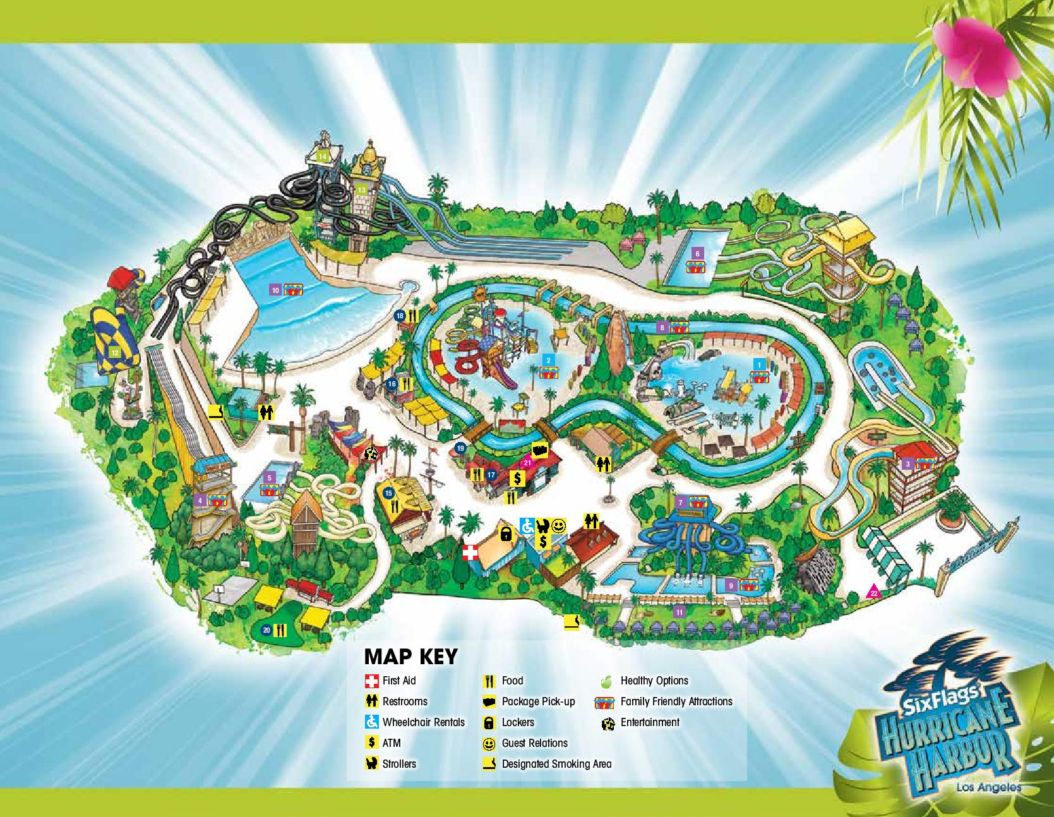

Region Facts
Midwest
- States included: Ohio, Indiana, Michigan, Illinois, Missouri, Wisconsin, Minnesota, Iowa, Kansas, Nebraska, South Dakota, North Dakota
- Climate: Humid continental climate throughout most of the region. Snow is common during the winter, especially in the northern areas.
- Major geographical features: Great Lakes, Great Plains, Mississippi River, borders Canada to the north
Southwest
- States included: Texas, Oklahoma, New Mexico, Arizona
- Climate: Semiarid Steppe climate in the western area with a more humid climate to the east. Some of the far western areas of the region have an alpine or desert climate.
- Major geographical features: Rocky Mountains, Colorado River, Grand Canyon, Gulf of Mexico, borders Mexico to the south
West
- States included: Colorado, Wyoming, Montana, Idaho, Washington, Oregon, Utah, Nevada, California, Alaska, Hawaii
- Climate: A range of climates including semiarid and alpine along the Rocky and Sierra Mountains. The coastline in California is a Mediterranean climate. Desert climates can be found in Nevada and Southern California.
- Major geographical features: Rocky Mountains, Sierra Nevada Mountains, Mohave Desert, Pacific Ocean, borders Canada to the North and Mexico to the south
Southeast
- States included: West Virginia, Virginia, Kentucky, Tennessee, North Carolina, South Carolina, Georgia, Alabama, Mississippi, Arkansas, Louisiana, Florida
- Climate: Humid subtropical climate with hot summers. Hurricanes can reach landfall in the summer and fall months along the Atlantic and Gulf coasts.
- Major geographical features: Appalachian Mountains, Atlantic Ocean, Gulf of Mexico, Mississippi River
Northeast
- States included: Maine, Massachusetts, Rhode Island, Connecticut, New Hampshire, Vermont, New York, Pennsylvania, New Jersey, Delaware, Maryland
- Climate: Humid continental climate with cool summers in the northernmost areas. Snow falls during the winter as the temperatures are regularly below freezing.
- Major geographical features: Appalachian Mountains, Atlantic Ocean, Great Lakes, borders on Canada to the north

Circle an option: |  | Ride | Food | Other
Based on which state?
Sketch:
Description:

